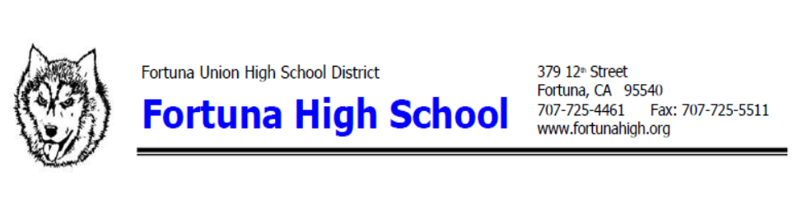
FORTUNA UNION HIGH SCHOOL PROFILE

Fortuna Union High School is a small public high school for grades 9 - 12 in a very rural part of California, five hours north of San Francisco. College of the Redwoods is the nearest community college, and Humboldt State University is 45 minutes north of us. The school has about 48% of our students on free/reduced lunch. All seniors complete a “Make a Difference” service project including at least 15 hours of community service before graduation.

Total Enrollment in 2020-2021: 819
Demographics:

White 58%
Hispanic 29%
Native American 11%
African American 1%
Asian 1%
Two or more races 8.6%

Academic Profile:

Planning to attend a four-year college after graduation: 30%
Planning to attend a two-year college after graduation: 50%
Planning to attend a vocational school after graduation: 10%
Seniors who have met the UC Entrance Requirements: 40%
Seniors who have completed a CTE Pathway:
Seniors who earned their Seal of Biliteracy in 2020 and 2021: 30

Grading Scale:

A = 4.0
- = 3.7
B+ = 3.3
B = 3.0
B- = 2.7
C+ = 2.3
C = 2.0
- = 1.7
D+ = 1.3
D = 1.0
- = 0.7
F = 0

Honors and Advanced Placement courses receive and extra grade point when computing GPA and
class ranks. High school students can also enroll at College of the Redwoods providing they meet the CR admissions criteria. In order to earn the extra grade point in the GPA calculation for CR classes, the class much be in the 1-99 course series and be transferable to the UC and CSU systems.

Honors Courses offered at FUHS: English 2, Chemistry, Pre-calculus, Statistics, Political Science, Physics, Symphonic Band, Camarada Singers.

AP Courses offered at FUHS: Calculus AB, Environmental Science, Biology, English 3A, English 4A, Government, US History, Spanish, Studio Art, Studio Art 2D.
Here is a list of cords that students can earn over their four years at Fortuna High:

ART
Red, Yellow & Blue Cord
4yrs. Program Completer

AUTOMOTIVE
Blue & Black Cord
4 yr. Program Completer

CULINARY ARTS
Blue & Silver Cord
4 yr. Program Completer

FUTURE FARMERS OF AMERICAN (FFA)
Blue & Gold Cord
4 yr. Program Completer

INDUSTRIAL TECHNOLOGY
Blue & Green Cord
4yr. Program Completer

LEADERSHIP
Blue & White Cord
4yrs. of Service to Fellow Students

MATHEMATICS
Gold, Silver & Bronze Cord
5 Math Classes in 4 yrs.

MUSIC
Pink Cord
4yrs. Program Completer

SCIENCE
Blue, Green & Silver Cord
5 Science Classes in 4 yrs.

CALIFORNIA SCHOLARSHIP FEDERATION (CSF)
Gold Honor Cord
4 Semesters in Good Standing w/one in Senior Year

COMMUNITY SERVICE
Copper Cord
100 hours or more

INTERACT CLUB - FORTUNA ROTARY
Teal & White Cord
2 years in club

MULTI-CULTURAL
Multiple Colored & Designed Sashes

N. CALIFORNIA COMMUNITY BLOOD BANK
Red Cord
3 or more blood donations

